Our Snow Excursion
We left on the bus at 1am Monday. Some people slept. Some people were sick. Some people drew pictures. We got to Jindabyne at 3pm. We unpacked the bus and got our snow gear.
On Tuesday, we caught the bus and two trains to Blue Cow. In the morning we had ski lessons for two hours. In the afternoon we had free time. Some people went skiing. Some people went on the chairlift. Some people had snow ball fights. Some people made a snowman called Twoey. The weather was perfect for skiing.
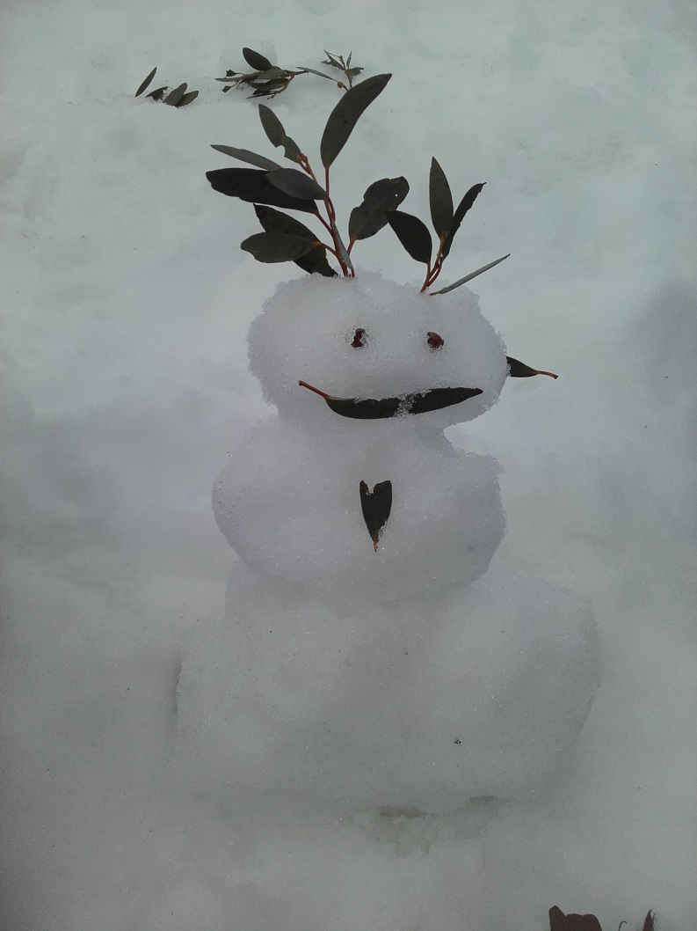
On Wednesday, it was very windy. Towards the end of our ski lesson it rained so hard that we had to go inside. When it stopped raining we went outside and it snowed. The snow was cold but it melted as soon as it fell on our clothes. Twoey was washed away by the rain.
On Thursday, the snow was deeper and softer. When we got to Blue Cow it was a blizzard. In our lesson we went down steeper slopes. Lots of us got blown over by the wind. Many of us got to ride on the chairlift and T-bar for the first time. Some of us made snow angels.
On Friday, we left Jindabyne at 7am and got back to school at 9:15 pm. We were glad to be home but want to go skiing again!!!
