2016 Excursion to the Snow
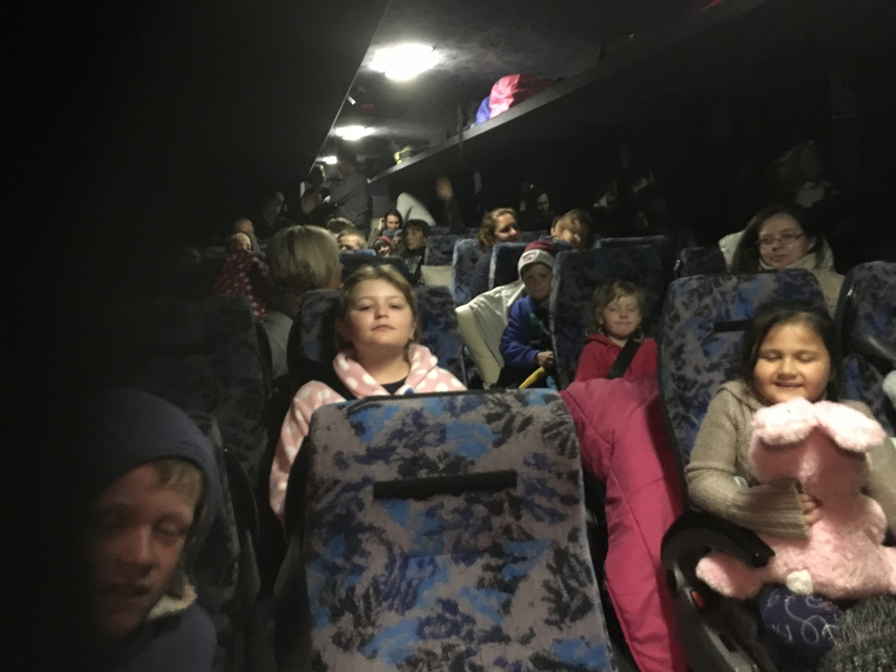
Monday the 12th of September
Gravesend Public School students, staff and parents departed at 1:00am on a Symes coach for the Jindabyne Snow Excursion. They travelled for 13 ½ hours to arrive at Jindabyne Sport and Recreation Centre at 3.15pm. The Sport and Recreation Centre leaders Monz and Michelle welcomed the students and explained the timetable for the Camp. Students were split into roll groups and ski groups, assigned to either Crackenback or Ramshead Lodges and fitted with ski gear. After dinner Michelle used a PowerPoint to explain the Alpine Responsibility Code.

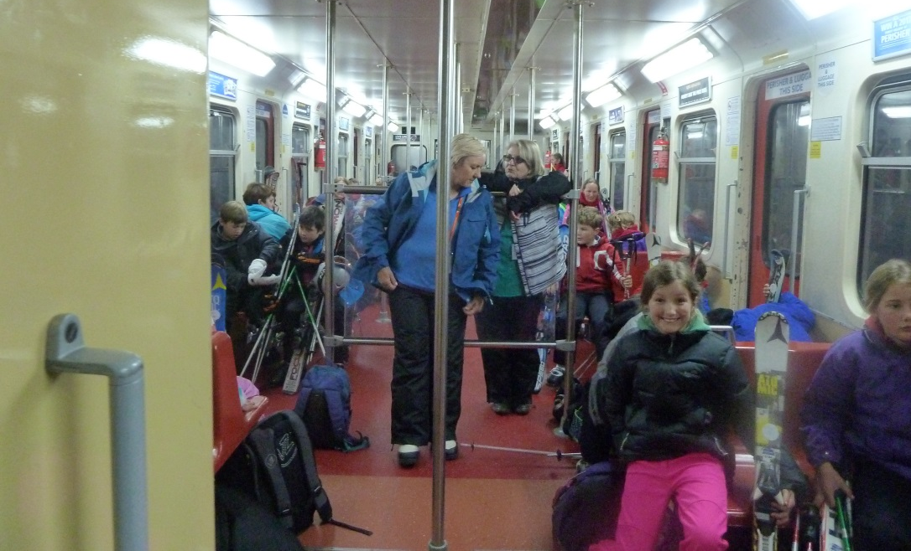

Tuesday 13th September
At 7.00am they travelled to Bullocks Flat by bus. Each student had to carry their ski gear so they put on their ski boots to make it lighter and boarded the Ski Tube to travel to Blue Cow. On arrival they headed to the Base Room to gear up for skiing. Monz and Michelle organised them into three groups and introduced them to their ski instructors Thomas, Tyler and Erin.
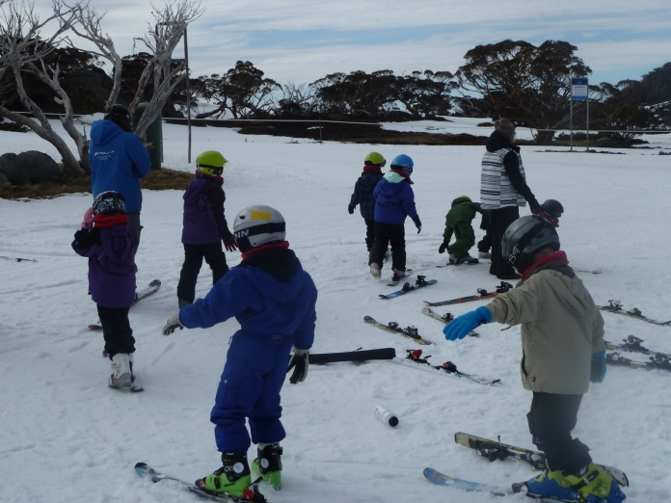
Thomas and Tyler took the beginners groups. Their lessons began with learning to balance on the left ski, then the right ski and then both.
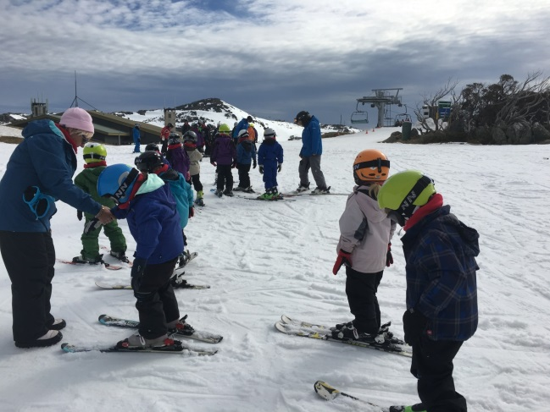

They were not allowed to use poles because they had to learn to balance by themselves. Next they learned how to do a pizza stop so they could go down the slope safely. To get back to the top they rode on the Magic Carpet and then they did it over and over again.

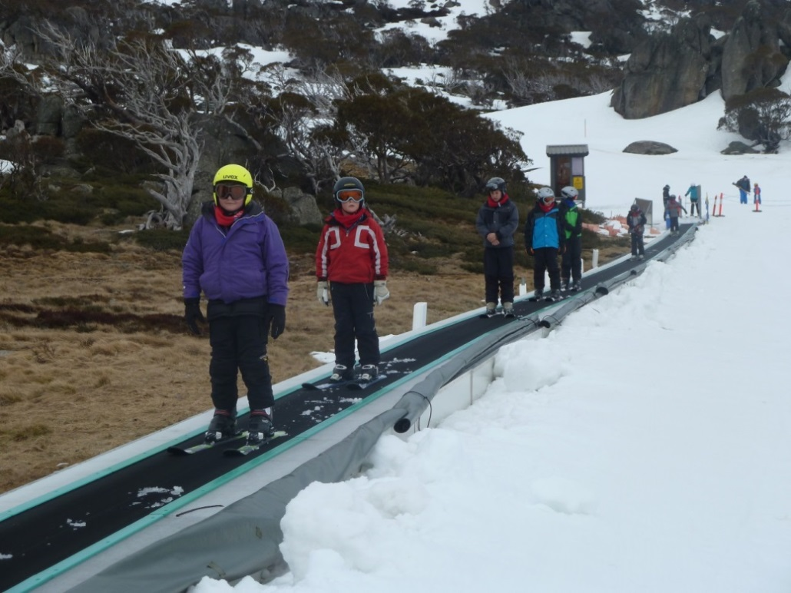

The Advanced Group’s instructor was Erin. They revised stops, turns and learned how to jump. Secondly they played a Traffic Light Game (Green – Go, Red - Stop, Yellow – Slow Down, Purple – Jump and Blue – Turn). Erin was happy with their skiing ability so she took them up the Pleasant Valley Quad Chairlift and they skied down the Blue Cow Home Run.
At 10.30am everybody had to be back for Roll Call at Base Room to ensure that nobody was lost on the slopes. There were two other Roll Call times – 12.00pm and 2.00pm. In between Roll Call times students were given free time to practice. Some students just played in the snow making Snowmen and having snowball fights.
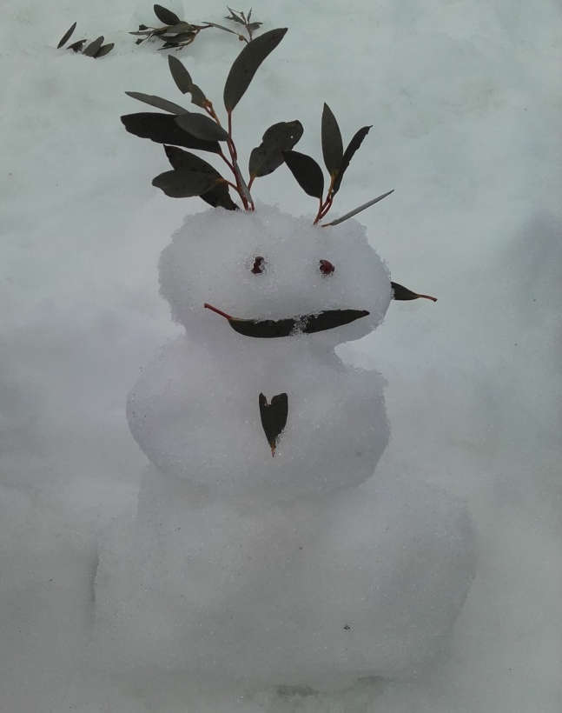
After the last free time and Roll Call it was home time. Fortunately all the gear could be left at Base Room so it didn’t have to be carried back and forth each day.
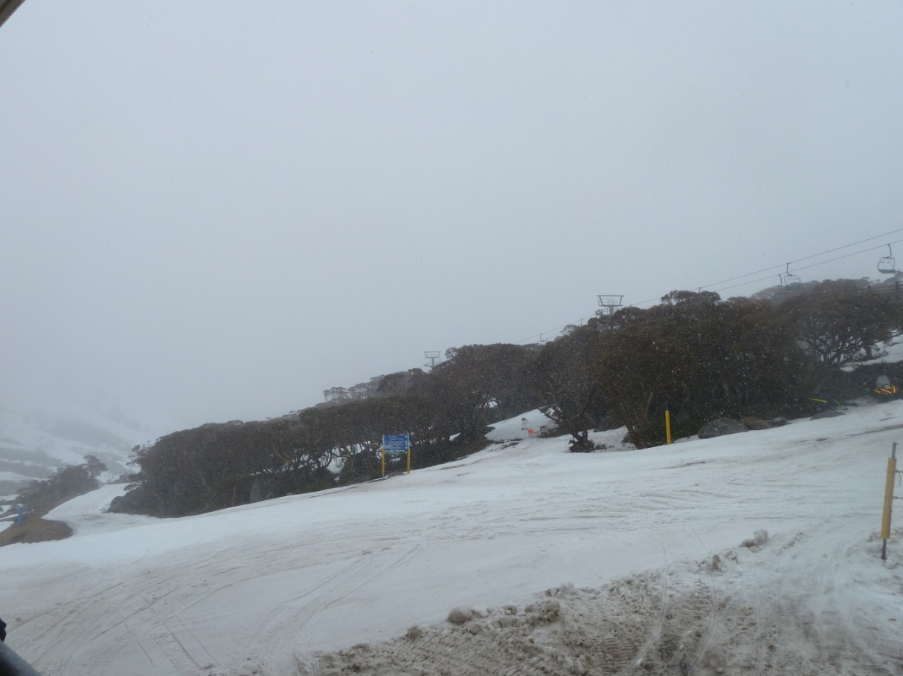

Wednesday 14th September
The weather for the second day was atrocious – wet, windy, rainy and sleety. Erin took the Advanced Group on the Brumby T-Bar to get up the mountain so they could ski down the steep Brumby Run. It was difficult to stay on the T-Bar and everyone fell off but no one was hurt. They all enjoyed the amazing experience so much they kept doing this for the rest of the day. Thomas and Tyler’s groups practised their skiing skills and learned how to turn going down the beginner’s slopes and back up on the Magic Carpet. A few kids fell off and it had to be stopped. In free time Monz taught some of them to ski backwards and she set up an obstacle course to practice turns. Others skied down the steep hill at the side of the beginner’s slope. As you can see the cold, rainy weather did not stop them from skiing and having a good time.
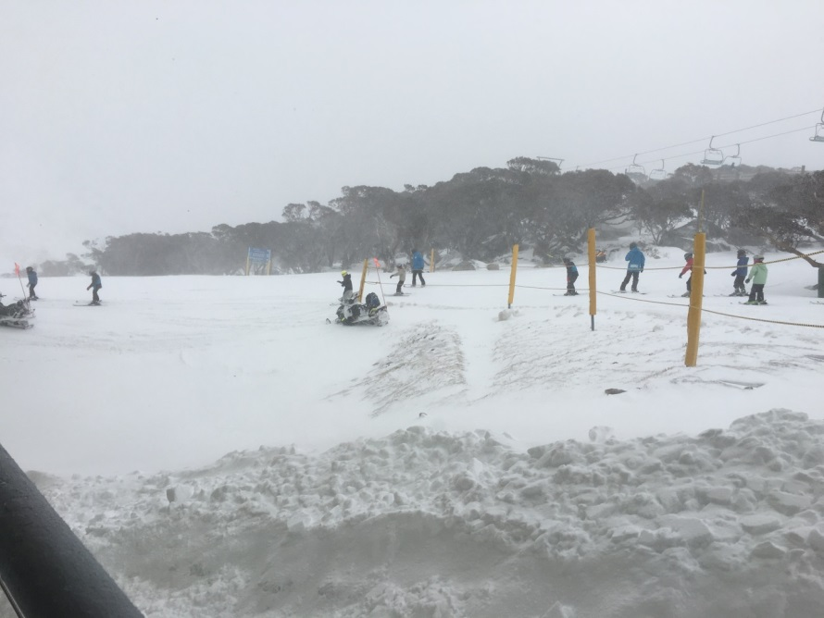

Thursday 15th September
The last day of skiing. On arrival at Bullocks Flat it was snowing wildly. What an amazing experience!
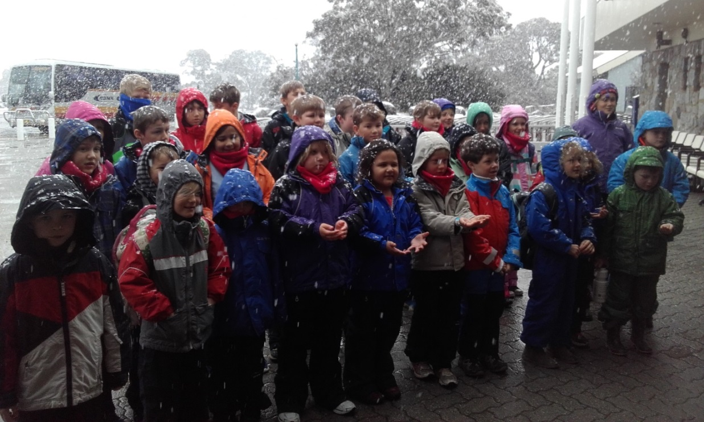
Thomas and Tyler’s groups had learned to ski so well they took them down the Terminal Run. The kids found this very challenging because the snow was powdery, the blizzard conditions covered their goggles in snow, the snow hitting their faces felt like being bombarded with pins and needles, the steep slope was covered in bumps, rocks and ice and it was hard to turn the corner at the bottom. Luckily they could catch the Terminal Quad Chairlift back to the top.
Erin was sick so the Advanced Group were instructed by Daniel. He took them down Pleasant Valley and up on the Brumby T-Bar. Next they went on a new run, Hideaway, which was very difficult due to the rocky steep slope. They used the T-Bar to return to the top. Finally he took them down the difficult section of the Terminal Run.

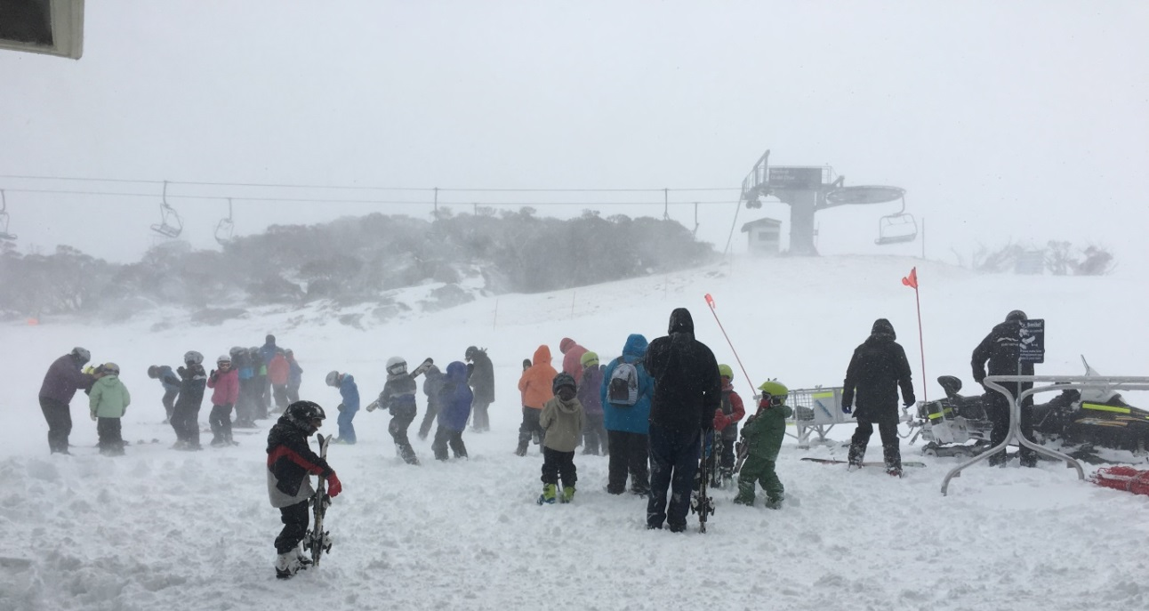

During free time the Advanced Group continued to ski while the other groups played in the snow.

Friday 16th September
The long trek home began at 7.00am reaching Gravesend Public School at 9.15pm.
Everyone had a fantastic time.
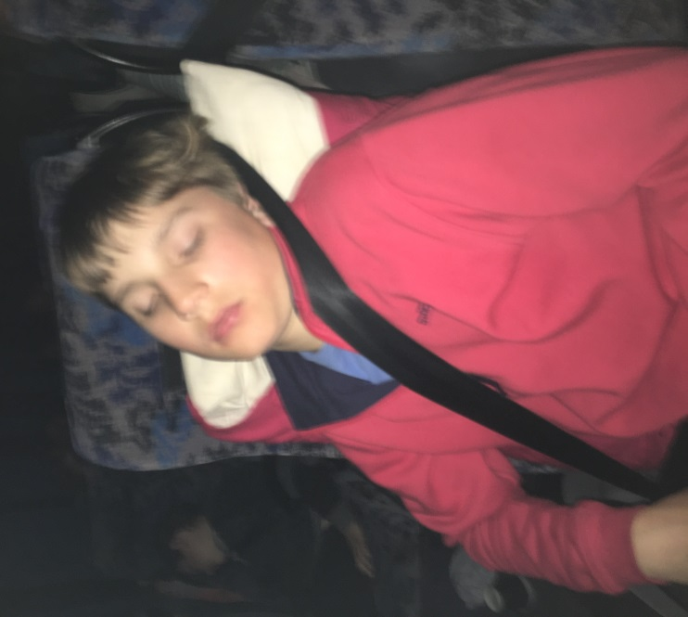
Erin / Dan’s Group Tyler’s Group Thomas’ Group
Sam Kirkby Caleb Withers Mariah Emelio
Flo Armstrong Jade Hicks Sarah Barwick
Tilly Barwick Alex Witten Tara Lysaght
Molly Armstrong Tommy Lysaght Roley van Velthuizen
Lola Barwick Flynn Kirkby Jock Kirkby
Henry Maunder Blake Brennan Clancy Barwick
Poppy Barwick William Barwick Michael Brennan
Charlie Peachey Sam Peachey
Ryan Goater Leilani Emelio
Os van Velthuizen Chloe Witten
Ben Witten Elly Withers
Ryan Brennan Joseph Dorney

